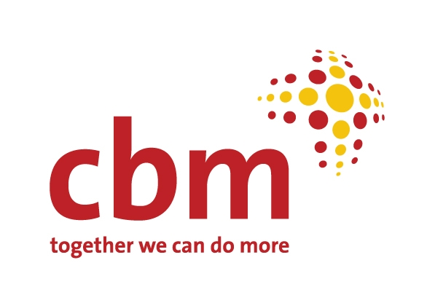

Partnership Framework Memorandum

(Memorandum of Understanding)

between
Please fill in name of the Partner
hereinafter referred to as “Partner”

Address/contact details:
Please fill in address/contact details

and
CBM Christoffel-Blindenmission Christian Blind Mission e.V.
Stubenwald-Allee 5
64625 Bensheim
Germany
Hereinafter referred to as “CBM” and represented by
The Country Representative
CBM is an international Christian development organisation whose primary purpose is to improve the quality of life of the world’s poorest Persons with Disabilities and those at risk of disability. CBM works in the most disadvantaged societies, irrespective of race, gender or religion.

CBM seeks to:
- Reduce the prevalence of diseases which cause impairments
- Minimise the conditions which lead to disability
- Promote equal opportunities for economic empowerment, livelihood security,
and full inclusion in all aspects of society for Persons with Disabilities.

The Partner: Please replace this text by giving a short abstract about the Partner's vision, mission, type of organisation.

In signing this Memorandum the Partner and CBM enter into partnership with the overall aim to improve the quality of life of the world’s poorest Persons with Disabilities and those at risk of disability.

Please replace this text by entering a short abstract describing the focus of the nature of the envisaged activities between the Partner/s and CBM.

This Memorandum of Understanding is the basis for support to be exchanged between the Partner and CBM in the form of funding, training, capacity development, technical support, resources, equipment and/or other type of support.
Any support can only be approved in conjunction with an agreed project plan.
Upon the agreement and approval of the project plan a project contract governing the objectives, indicators and funding will be signed between the Partner and CBM.
The planning process leading up to the project plan should be a joint venture between the Partner and CBM.
Professional advice and capacity building in project planning and management can be requested by the Partner from CBM.

In their partnership the Partner and CBM will work together towards achieving local ownership and responsibility. The Partner and CBM through dialogue, capacity building, mutual knowledge transfer and learning will strive together to achieve a sustainable programme and development.

The partnership between the Partner and CBM is based on the following
guiding principles:

We aspire to similar values
It is important that we have similar values that are shared and respected.

We share a common vision
We work towards a common objective by sharing a common vision.

We seek mutual respect and trust
One of the key principles of partnership is the respect for one another’s strengths and challenges. Mutual trust is the foundation of all partnerships and all efforts need to be made to develop and maintain trust.

We are committed to mutual transparency
Transparency builds up trust and credibility and needs to be maintained in all fields of partnership. We are both willing and will actively promote frequent open and honest communication and will annually exchange the respective activity reports.
We agree on mutual accountability
As Partners we are committed to holding each other accountable for all areas of partnership; be it professional, financial, managerial or otherwise. We agree to meet obligations stated in the project contracts to be developed.

We are committed to the realisation of human rights
We respect and seek to realise every person’s full potential and their legitimate position in the family, community and society.

We promote gender equality
Women and men, girls and boys have equal rights to the opportunities, resources, responsibilities and goods enjoyed by the rest of the community. These should be enjoyed by all irrespective of gender.

We aim to protect children and their rights
Children must be protected from neglect and physical, emotional and sexual abuse. CBM’s Child Safeguarding Policy can help create and maintain a child-safe environment.
In signing this Memorandum of Understanding we agree to adhere to the afore-mentioned principles and establish a working partnership. This Memorandum of
Understanding is subject to a review approximately every 3 years, in which both parties will discuss and agree on the future of the partnership. Should either party wish to significantly change or end the partnership an open discussion of the reasons for change or cessation of the partnership will take place before a final decision is made.

Signatures (two copies, one for each party):
For the Partner:  (authorised signatory) |  | For CBM:  (authorised signatory)
Name |  | Name
Function |  | CBM Country Representative
Place, date and stamp |  | Place, date and stamp
For the Partner:  (second signatory, optional) |  | For CBM:  (signature of authorised employee)
Name |  | Name
Function |  | Function
Place, date and stamp |  | Place, date and stamp

